

**NUST**

**School of Mechanical & Manufacturing Engineering**

**FOP Assignment:**

**Name:** Muhammad Muzammil Riaz

**Qalam:** 467817

**Batch:** ME-15

**Section:** A

**Course Instructor:** Dr. Jawad

**Lab instructor:** Sir. Saqib

1. Write a program in C++ that prints the numbers from 1 to 150 except the multiples of 10.

Make use of the continue statement.

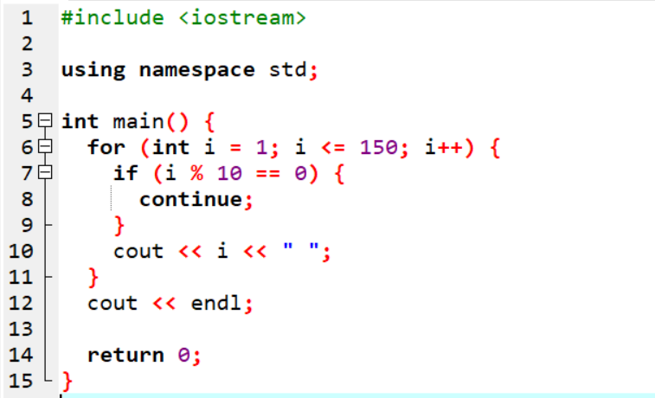

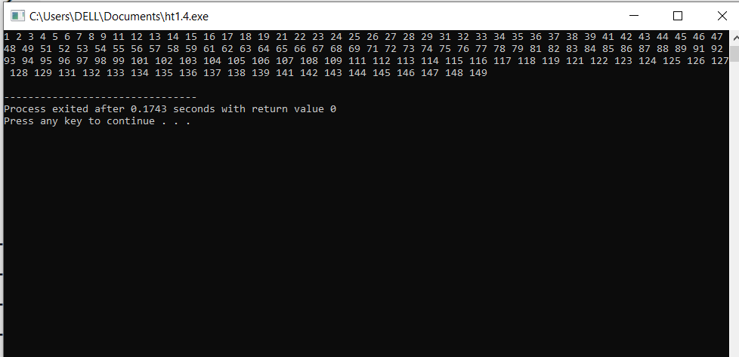

1. Write a C++ program to find the sum of digits of a number.

The sum of digits means adding all the digits of any number, for example, we take any number like 358. Its sum of all digits is 3+5+8=16.

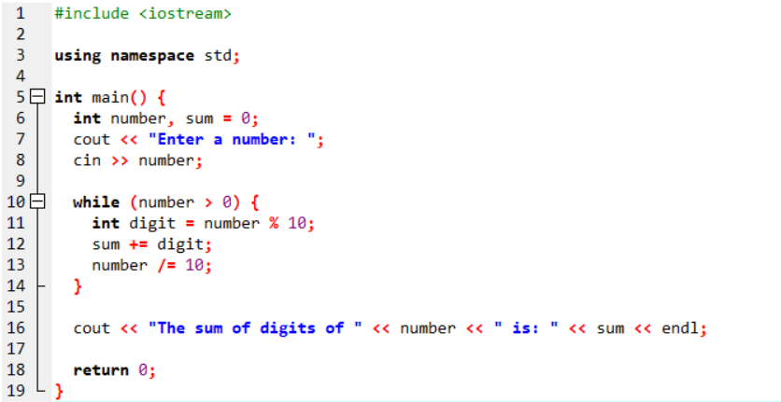

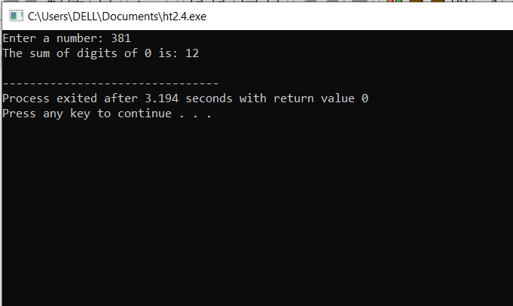

1. Write a program in C++ to check whether a number is prime or not.

